
Processing Data of Aadhar Id Cards
Using Hadoop
MINOR PROJECT REPORT
SUBMITTED IN PARTIAL FULFILMENT OF THE REQUIREMENTS FOR THE AWARD OF THE DEGREE OF
BACHELOR OF TECHNOLOGY
IN
COMPUTER ENGINEERING

BY

PALASH KULSHRESHTHA ARUN KUMAR ATTRI
11-PEB-140 11-PEB-156
GE-6129 GE-6161

Under the Supervision of
Mr. Nadeem Akhtar
Ms. Farheena Khan

DEPARTMENT OF COMPUTER ENGINEERING
ZAKIR HUSSAIN COLLEGE OF ENGINEERING & TECHNOLOGY
ALIGARH MUSLIM UNIVERSITY
ALIGARH (INDIA)-202002
(2012)
ZAKIR HUSSAIN COLLEGE OF ENGINEERTNG & TECHNOLOGY
ALIGARH MUSLIM UNIVERSITY
ALIGARH-202002 (INDIA)

CERTIFICATE

This is to certify that the project entitled “Processing Data of Aadhar Id Cards Using Hadoop” is being submitted by Palash Kulshreshtha & Arun Kumar Attri in the partial fulfilment for the award of the B.Tech Degree in Computer Engineering, Department of Computer Engineering ZHCET, AMU, Aligarh is a record of their own work carried out under my supervision and guidance.

(Mr. Nadeem Akhtar)
Department Of Computer Engineering
ZHCET, AMU

ACKNOWLEDGEMENT

Successful completion of this project would have been an unachievable dream without the thorough guidance and help of our project guides Mr Nadeem Akhtar and Ms Farheena. Working under their supervision has been an excellent learning experience.
We are extremely thankful to Mr Juned Ansari for his continuous help and encouragement.
Moreover we are indebted to Ms Poonam Attri (IBM Ltd.) and Mr Prabeer Patra (Guavus Ltd) for their valuable insights and helping us orient our project with the current industry standards. We would also like to thank our lab assistant Mr Musabbir for helping us in times of need.
Last but not at all the least we would like to thank our families without whom we would not have seen this day.

Palash Kulshreshtha & Arun Kumar Attri
B.Tech 5thSem

Contents
Abstract................................................................................................................................................. 6
Concepts 7
1.1 Introduction to Big Data? 8
1.2 Introduction to Distributed File System 8
1.3 Introduction to MapReduce 9
1.4 Big-Data and Hadoop Relevancy 9
1.5 Introduction to High Availability Clusters 10
Tools Used 11
2.1 Hadoop 12
2.1.1 Hadoop Daemons 12
2.1.2 HDFS 13
Features of HDFS 13
2.2 Bash 13
2.3 Java 13
2.4 Visual Studio 14
2.5 R-Base 14
2.6 Awk 14
JobRun 15
3.1 Setting up Hadoop Cluster 16
3.2 Starting Hadoop daemons 16
3.3 Data Transfer to HDFS 16
3.4 Submitting Map reduce Job 16
3.5 Retrieving Results 17
3.6 Visualising the extracted data 17
3.7 Publishing the results 17
We have plotted the graphs on 17
Web Application UI 21
4.1 Web App UI 22
4.2 High-Level Architecture 22
Conclusion And Future Works 23
5.1 Conclusion 24
5.2 Future Improvement Avenues 24
Bibliography 25

ABSTRACT
The only thing that beats the pace of growing population is growing digital data. With increasing use of computers and other digital devices in every walk of life, the rate at which data is being collected is beyond all bounds. Facebook alone generates 1-2 TB of data every day.
So Avenues of data generation in this multi-billion populated country are unlimited. This demands India to be ready to face the gruesome task of processing its Terabytes and Petabytes of data. Only recently government of India made public few of its official data, one of that was pertaining to Aadhar id cards generated.
With Unique ids being a reality in near future, the rate of Aadhar cards generation would steeply increase. This would create demand for determining trends from previously generated cards like male to female participation etc. This kind of information would equip our administrators in designing suitable policies to attract even more people to participate.
With this as our motivation we designed our project to process Aadhar id cards data on a simulated Hadoop cluster. The Processed data would be statistically computed with R base scripts and graphically plotted for visual interpretation. Finally all the results will be compiled in an ASP.net web application. It can be hosted on internet or intranet and results can be made available throughout the administrative departments.

Chapter 1

Concepts

Introduction to Big Data?
Big data is the term for a collection of so large and complex that it becomes difficult to process using on-hand database management tools or traditional data processing applications. The trend to larger data sets is due to the additional information derivable from analysis of a single large set of related data, as compared to separate smaller sets with the same total amount of data, allowing correlations to be found to spot business trends, determine quality of research, prevent diseases, link legal citations, combat crime, and determine real-time roadway traffic conditions.
Big data is difficult to work with using most relational database management systems and desktop statistics and visualization packages, requiring instead massively parallel software running on tens, hundreds, or even thousands of servers. What is considered "big data" varies depending on the capabilities of the organization managing the set, and on the capabilities of the applications that are traditionally used to process and analyze the data set in its domain.

Introduction to Distributed File System
A distributed file system is a client/server-based application that allows clients to access and process data stored on the server as if it were on their own computer. When a user accesses a file on the server, the server sends the user a copy of the file, which is cached on the user's computer while the data is being processed and is then returned to the server.
Ideally, a distributed file system organizes file and directory services of individual servers into a global directory in such a way that remote data access is not location-specific but is identical from any client. All files are accessible to all users of the global file system and organization is hierarchical and directory-based. Since more than one client may access the same data simultaneously, the server must have a mechanism in place (such as maintaining information about the times of access) to organize updates so that the client always receives the most current version of data and that data conflicts do not arise. Distributed file systems typically use file or database replication (distributing copies of data on multiple servers) to protect against data access failures. Distributed file systems do not share block level access to the same storage but use a network protocol.

Introduction to MapReduce
MapReduce is a programming model for processing large data sets with a parallel, distributed algorithm on a cluster.
A MapReduce program is composed of a Map() procedure that performs filtering and sorting and a Reduce()procedure that performs a summary operation. The MapReduce framework operates by marshalling the distributed servers, running the various tasks in parallel, managing all communications and data transfers between the various parts of the system, and providing for redundancy and fault tolerance. A popular open-source implementation is Apache Hadoop. The name MapReduce originally referred to the proprietary Google technology but has since been genericized.
MapReduce can take advantage of locality of data, processing data on or near the storage assets to decrease transmission of data.
The Map and Reduce functions of MapReduce are both defined with respect to data structured in (key, value) pairs:
"Map" step: The Map function is applied in parallel to every pair in the input dataset. This produces a list of pairs for each call.
Map(k1,v1) → list(k2,v2)
After that, the MapReduce framework collects all pairs with the same key from all lists and groups them together, creating one group for each key.
"Reduce" step: The Reduce function is then applied in parallel to each group, which in turn produces a collection of values in the same domain:
Reduce(k2, list (v2)) → list(v3)
Each Reduce call typically produces either one value v3 or an empty return, though one call is allowed to return more than one value. The returns of all calls are collected as the desired result list.

Big-Data and Hadoop Relevancy
The "Big Data" phrase refers to the necessity to deal with large amounts of data and the most popular solution is provided by Hadoop. Indeed, this software handles wide datasets by splitting them into chunks that are scattered among a cluster of computers. As regards the hardware, the Hadoop advantage is that it may use a cluster of cheap computers. In addition, larger volumes may be handled through adding some new nodes.

Introduction to High Availability Clusters
High-availability clusters (also known as HA clusters or failover clusters) are groups of computers that support server applications that can be reliably utilized with a minimum of down-time. They operate by harnessing redundant computers in groups or clusters that provide continued service when system components fail. Without clustering, if a server running a particular application crashes, the application will be unavailable until the crashed server is fixed. HA clustering remedies this situation by detecting hardware/software faults, and immediately restarting the application on another system without requiring administrative intervention, a process known as failover. As part of this process, clustering software may configure the node before starting the application on it. HA clusters are often used for critical databases, file sharing on a network, business applications, and customer services such as electronic commerce websites.
HA cluster implementations attempt to build redundancy into a cluster to eliminate single points of failure, including multiple network connections and data storage which is redundantly connected via storage area networks.

Chapter 2

Tools Used

Hadoop
Apache Hadoop is an open source framework for developing distributed applications that can process very large amounts of data. It is a platform that provides both distributed storage and computational capabilities. Hadoop has two main layers:
- Computation layer: The computation tier uses a framework called MapReduce.
- Distributed storage layer: A distributed file system called HDFS provides storage.

Hadoop Daemons
The main Hadoop daemons are specified below:
- Namenode : The namenode is the heart of the hadoop distributed filesystem architecture. It manages the file system namespace and regulates access to files by clients. HDFS exposes a file system namespace and allows user data to be stored in files.
- DataNode : The DataNodes are responsible for serving read and write requests from the file system’s clients. The DataNodes also perform block creation, deletion, and replication upon instruction from the NameNode.
- Jobtracker : This hadoop daemon is present on the master node and keeps track of running jobs in hadoop framework. When a client assigns a new job then the jobs are submitted to the job tracker .It is the task of the jobtracker to find the relevant datanode for the task who have relevant data for the task.
- Tasktracker : Once the jobtracker sends the code to the datanodes. It’s the task of the task tracker daemons to accept the jobs from the job tracker and run it on the data present on it locally.
- Secondary-Namenode : The basic task of the secondary namenode is to regularly contact the namenode and copy the namespace mapping of blocks to files from namenode’s main memory to its hard disk. The secondary namenode cannot be used as backup namenode.

HDFS
The Hadoop Distributed File System (HDFS) is the primary storage system used by Hadoop applications. HDFS is a distributed file system that provides high-performance access to data across Hadoop clusters.
Because HDFS typically is deployed on low-cost commodity hardware, server failures are common. The file system is designed to be highly fault-tolerant, however, by facilitating the rapid transfer of data between compute nodes and enabling Hadoop systems to continue running if a node fails.
When HDFS takes in data, it breaks the information down into separate pieces and distributes them to different nodes in a cluster, allowing for parallel processing. The file system also copies each piece of data multiple times and distributes the copies to individual nodes, placing at least one copy on a different server rack than the others. As a result, the data on nodes that crash can be found elsewhere within a cluster, which allows processing to continue while the failure is resolved.

Features of HDFS
- It is a ‘write once and read many times’ type of DFS.
- It stores the file in blocks of size 64MB.
- In HDFS data is replicated on multiple nodes depending on the replication ratio.
- It is implemented in Java.

Bash
Bash (Bourne Again Shell ) is the free version of the Bourne shell distributed with Linux and GNU operating systems. Bash is similar to the original, but has added features such as command line editing. It is intended to conform to the shell standard specified as part of IEEE POSIX

Java
Java is a high-level programming language developed by Sun Microsystems. It is an object-oriented language similar to C++, but simplified to eliminate language features that cause common programming errors. Java source code files (files with a .java extension) are compiled into a format called bytecode (files with a .class extension), which can then be executed by a Java interpreter. Compiled Java code can run on most computers because Java interpreters and runtime environments, known as Java Virtual Machines (VMs), exist for most operating systems, including UNIX, the Macintosh OS, and Windows. Bytecode can also be converted directly into machine language instructions by a just-in-time compiler (JIT).

Visual Studio
Microsoft Visual Studio is an integrated development environment (IDE) from Microsoft. It is used to develop console and graphical user interface applications along with Windows Forms or WPF applications, web sites, web applications, and web services in both native code together with managed code for all platforms supported by Microsoft Windows, Windows Mobile, Windows CE, .NET Framework, .NET Compact Framework and Microsoft Silverlight.
Visual Studio supports different programming languages by means of language services, which allow the code editor and debugger to support (to varying degrees) nearly any programming language, provided a language-specific service exists. Built-in languages include C/C++ (via Visual C++), VB.NET (via Visual Basic .NET), C# (via Visual C#).

R-Base
R is a language and environment for statistical computing and graphics. It provides a programming language, high level graphics, interfaces to other languages and debugging facilities.
The R language is a dialect of S which was designed in the 1980s and has been in widespread use in the statistical community since.
The language syntax has a superficial similarity with C, but the semantics are of the FPL (functional programming language) variety with stronger affinities with Lisp and APL. In particular, it allows “computing on the language”, which in turn makes it possible to write functions that take expressions as input, something that is often useful for statistical modelling and graphics.

Awk
AWK is an interpreted programming language designed for text processing and typically used as a data extraction and reporting tool. It is a standard feature of most Unix-like operating systems.

Chapter 3

JobRun

3.1 Setting up Hadoop Cluster
We have configured 2 node pseudo distributed cluster in hadoop which implies that both the nodes run on the same system in multiple JVMs. The datanodes have been configured to run on port number 50022 and on default port. Other important configurations have been specified in the conf (default properties) and conf2 folder supplied with the documents.

3.2 Starting Hadoop daemons
Once the cluster has been configured, all the required daemons are started. The default configuration daemons are started by running the predefined script start-all.sh. The daemons on the extra node are started by running hadoop-daemon.sh with extra arguments for starting datanode and its Tasktracker.

3.3 Data Transfer to HDFS
The hadoop framework's map reduce classes i.e. Mapper and Reducer can process data that is present in the HDFS. So before submitting a map reduce job, we have to transfer our aadhar data from our local machine to HDFS. During the transfer process the HDFS breaks the file into number of blocks and stores all of them on both nodes. This is consistent with the fact that replication factor is 2. We have specified this replication factor in hdfs-site.xml in configurations (both) folders. The default block size has been 64 MB.

3.4 Submitting Map reduce Job
To process the data we supplied a jar file containing compiled classes from aadhar.java and Tokens.java. Aadhar.java contains job description as well as mapper and reducer classes. Tokens.java contains personalised class which works somewhat similar to stringtokenizer class. Once the job has been successfully submitted ,it will start running on the datanodes available and percentage of maps and reduce completed are shown simultaneously.

3.5 Retrieving Results
Once the job has been successfully completed the results from the job are stored on HDFS in a directory specified in job run parameters. The data is transferred from HDFS to local file system where it is accompanied by history of logs and a success document.

3.6 Visualising the extracted data
We have used R language to perform statistical calculations on the results. Once the results have taken the desired form (i.e. in the form of matrix or data frame) the plots are generated by writing suitable R scripts.

3.7 Publishing the results
There are numerous scenarios in which the results from our project can be used. They can be used one time by a single person or committee; in that case it is best suitable to provide the report consisting of processed results and their respective graphs. But in a scenario in which the extracted results are used over a period of time by a group of users, it is best suitable to publish the results on a web application (asp.net application in our case). It enables best use of the results to design better policies related to aadhar ID cards.

We have plotted the graphs on:
- Total aadhar cards generated and not generated
- Age wise aadhar id cards generated
- Male to female ratio of Aadhar Id card distribution scatter
- State wise Male to female aadhar id cards generated
- Overall male to female participation in all states.
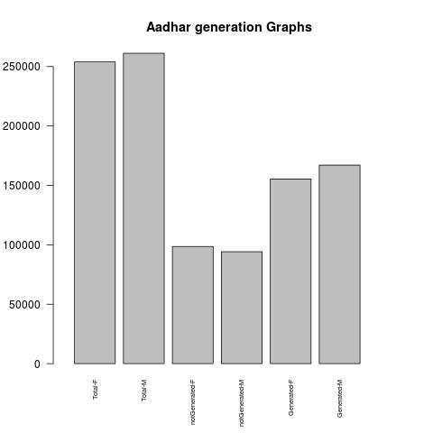
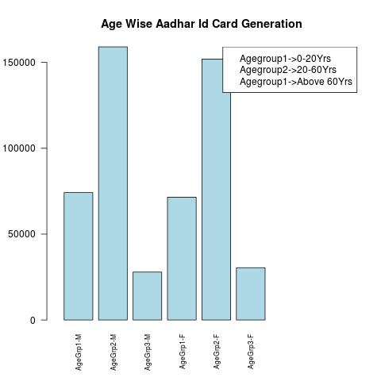
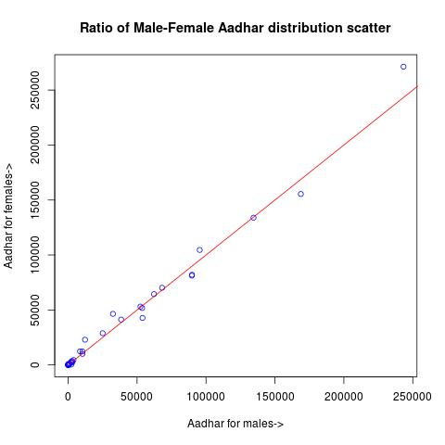

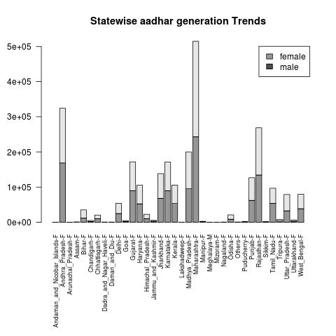
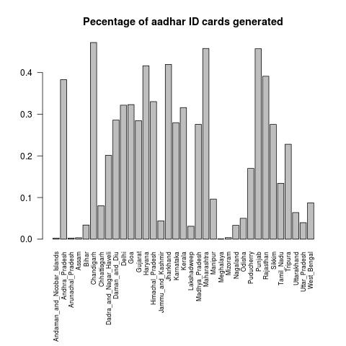

Chapter 4

Web Application UI

4.1 Web App UI
The graphs that have been generated from Aadhar Id Card data has been published on a Web Application which can be hosted on the internet. The Web App also contains the summary of our project and the important tools used. This Web App has been developed in Asp.Net framework using Microsoft Visual Studio 2008.

4.2 High-Level Architecture
The Web application has been divided into 3 main parts.
- Introduction: it consists of the basic introduction to our project.
- Project Videos: Our Project being primarily CLI based job run videos have been attached in this section.
- Reports and Aadhar Visualizations: This section contains the graphs that were generated in previous sections.

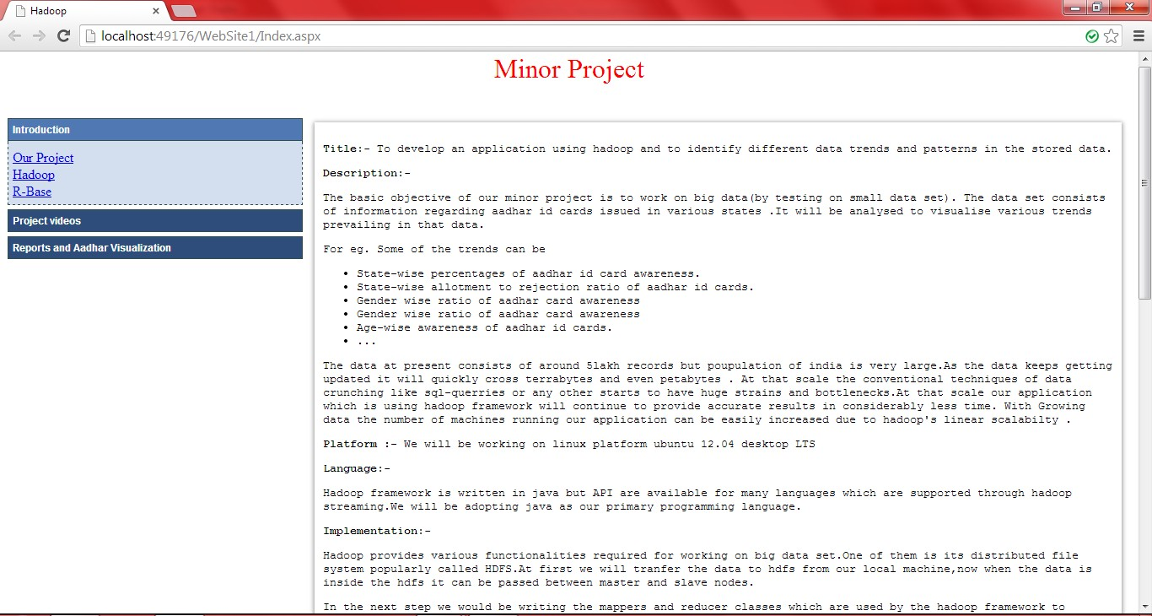

Chapter 5

Conclusion And Future Works

5.1 Conclusion
At last we would like to conclude that as size of data starts to outgrow the processing power of single machine, Hadoop starts to outshine everyone. It stands as sole contender for processing big data efficiently.
Moreover with the sequence of operations that we have adopted in this project, Government departments can easily set up their own data processing facility .

5.2 Future Improvement Avenues
This project can be extended in numerous ways in future. We had already started to extend it to create real physical cluster consisting of two ubuntu systems equipped with Hadoop.
Lack of relevant data provided on data.gov.in became the bottleneck of our project. With arrival of new big data the real power of our project can be harnessed.
We can also extend to work with other open data present on the internet and generate relevant graphical reports.

Bibliography
- Hadoop- the definitive guide by: Tom white
- http://mysolvedproblem.blogspot.in/2012/05/installing-hadoop-on-ubuntu-linux-on.html
- Data-Intensive Text Processing with MapReduce by Jimmy lin and Chris Dyer
- The Google File System By Sanjay Ghemawat, Howard Gobioff, and Shun-Tak Leung @Google
- www.Stackoverflow.com in general helped on few frequent problems
- http://hadoop.apache.org common source for all Hadoop documentation
- R-base help documentation supplied with the package
- Manual pages of Linux utilities like awk, grep etc used in this project
- http://forums.asp.net/ was helpful in solving issues faced while developing web application
- Ajax control toolkit documentation helped us in getting familiar with the toolkit
- Après – beginning asp.net 3. From novice to professional second edition

